**Short report of results obtained in analysis of mussels sent by Sara Kingston**

We analyzed the morphotypes of shells from 12 populations. The morphotype was assessed due to level of development of nacreous layer under ligament nympha (see Katolikova et al, 2016; Khaitov et al., 2018).

Shortly the morphotype assessment technique could be described as follow. We investigated the inner surface of dry shells under dissecting stereo-microscope and we assessed if the nacre cover the prismatic layer in the nympha region (Fig.1).

Those mussels which have uncovered prismatic layer (Fig. 1 a, b) we classified as mussels of T-morphotype. Importantly (!), mussels from the White Sea and the Barents Sea possess rather broad stripe of uncovered prismatic layer (Fig 1 a) and the color of the prismatic material is rather dark (that’s why we denoted this trait “dark stripe under ligament" in Katolikova et al, 2016). However, rarely, in material from White and Barent Sea, the nacreous layer grows so much that the strip of the prismatic layer becomes very narrow (Fig. 1b) but in this case it could be well traced. In the case of American samples we found two particularities of mussels of T-morphotype. 1) The stripe of prismatic layer is practically in all cases was very narrow. 2) The color of this stripe never was dark (but by structural features this strip can be easily recognized).

Those mussels which have nacreous layer covered prismatic layer under ligament nympha were classified as E-morphotype. However some quantitative variation of the degree of nacreous coverage could be recognised. In some cases nacre cover all space under nympha (Fig. 1 c) but in other cases the prismatic layer could be traced like a small gulf intruding into nacreous layer (Fig 1 d). That’s why we assessed additionally so called Z-index (see also Khaitov et al., 2018) which is the ratio of distance from the umbo to the anterior boundary of the “gulf” of prismatic layer (values “a” in the file with data and in Fig. 1 d) to the distance from umbo to the posterior boundary of ligament (values “l” in the file with data and in Fig. 1 d). In the case of T-morphotype Z = 0.

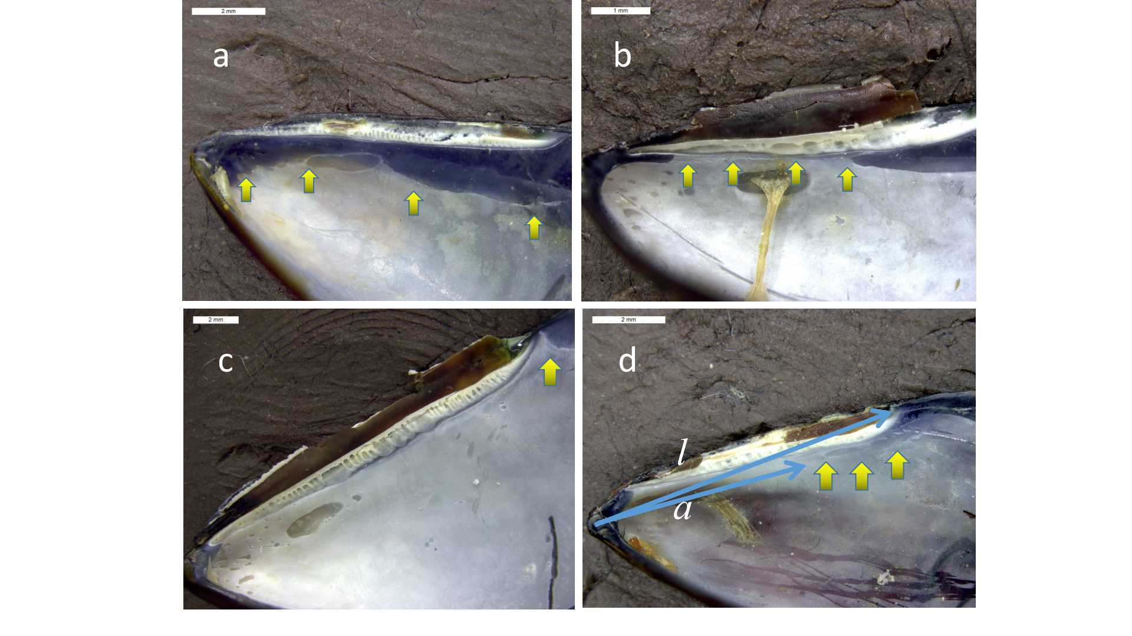

Fig 1. The patterns of nacreous layer presence in the ligament area.

We constructed the distribution of Z-index for each population investigated (Fig. 2). In general the distributions are equal to those observed in the White Sea populations (Fig. 3). However one problem was found. In all cases in the White Sea we can see that most of M.trossulus possess rather low Z-index. In the case of American pure M.trossulus population (CBE) we can see the same pattern. In the case of three mixed populations (MDRE, MDRW, CBSL) we see practically the same pattern which we found in the mixed populations in the White Sea (populations voronya, ryazh_f). However in the case of two mixed populations CBSC and CBCP from American samples we found absolutely another pattern: M.trossulus possess the pattern of Z-index distribution close to the pattern which is usual for M.edulis.

What is that? Is it unexpected biological phenomena or some mistake in database?



Fig. 2. Distribution of Z-index in the samples that were provided by Sara Kingston. Populations are ordered accordingly to proportion of M.trossulus (strucuture score > 0.5) in total amount of mussels. The value in the middle of each chart is the proportion of M.trossulus. Violins filled by red are those populations which included into paper Kingston et al., 2017 (should be proofed).



Fig. 3. Distribution of Z-index in the samples from the White Sea.